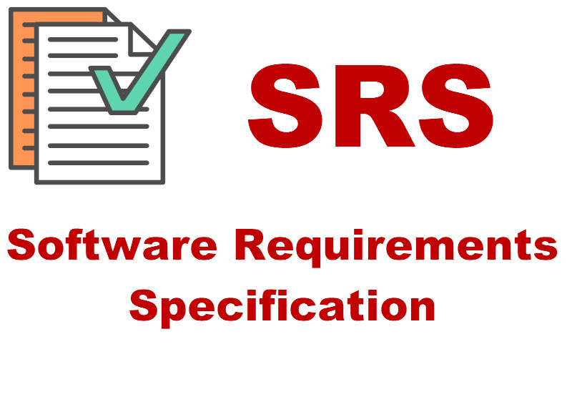

**Web Developer Portfolio**

**SRS**

Contents

**Purpose** 2

**SCOPE** 3

**INTRODUCTION** 3

**Existing System** 3

**Proposed System** 4

**FUNCTIONAL REQUIREMENTS** 4

**NON-FUNCTIONAL REQUIREMENTS** 4

**SOFTWARE TOOLS** 4

**DEPLOYMENT** 4

**HARDWARE SPECIFICATION** 5

**Developer’s Portfolio**

**Category:** Web Development -Portfolio

# **Purpose**

The purpose of developing this portfolio is-

# **The purpose of this Software Requirements Specification (SRS) document is to define the requirements and specifications for a web developer's portfolio static website.**

# **SCOPE**

The scope of this project is to create a static website that showcases the web developer's skills, expertise, and previous work experience. The website will also include a contact form for potential clients to get in touch.

1. Search and filtering: This includes features for visitors to search for specific projects or technologies and to filter results by date, technology, or project type.
2. Technology stack: This includes the specific technologies, programming languages, and frameworks used to develop the portfolio.
3. Security: This includes measures to ensure the portfolio is secure and protects user information and data, such as secure authentication methods and hosting on a secure server.
4. Analytics: This includes integration with analytics tools, such as Google Analytics or similar, to track user behaviour and performance.
5. Support and maintenance: This includes features to make the portfolio easy to maintain and update by the developer and to provide support and documentation for visitors and potential clients.

# **INTRODUCTION**

## **Existing System**

The present system is a manual system or a semi-automated system. Manual system involves paper work in the form of maintaining various files and manuals. Maintaining critical information in the files and manuals is full of risk and a tedious process.

A manual system has following disadvantages

It’s a limited system and fewer users friendly.

✓ Searching of particular job information is critical it takes lot of time.

✓ In the existing system developers need to visit and apply by self in companies.

✓ In the manual system developer need bare the lot of time and cost.

✓ The existing system needs to save the information in the form of files.

## **Proposed System**

As the Developer’s Portfolio is one that aims to give the candidate experience equal to or better than sort they would find in a traditional job. There are obviously many advantages of the developer’s portfolio.

Advantages are: -

✓ **About:** It has information related to developer in detail.

✓ **Skills:** It show that what type of skill have in developer.

✓ **Experience:** It tells about the past work experience in companies.

✓ **Project:** It includes all type of work did in companies and college time.

## **FUNCTIONAL REQUIREMENTS**

"Functional requirement describe what a developer should do." Functional requirements of our system are explained below.

✓ Users must have website name to visit on it.

✓ Company’s HR can see about the developer and skill.

✓ Project created by himself in company or

✓ There can be platform to discuss various queries and to put up suggestions posted both by developer and HR.

✓ Developer can send portfolio to the company for job.

✓ HR may contact to the developer using social media options.

* The portfolio should be easy to maintain and update by the developer and provide support and documentation for visitors and potential clients.

## **NON-FUNCTIONAL REQUIREMENTS**

* Requirement that specifies criteria that can be used to judge the hiring of a candidate are called Non functional requirements. Non functional requirements of our system are mentioned below

✓ Less time require for knowing skill of candidate.

✓ Better information related to the developer.

✓ Flexible service-based project will be highly desirable for future extension.

✓ Teacher registration facility is accessible by administration only.

## **SOFTWARE TOOLS**

**Client:** Microsoft Internet Explorer or any web browser

**Development Tools:** Visual Studio Code.

**Programming Language:** HTML, CSS, JavaScript

## **DEPLOYMENT**

**Operating System Server:** Window 10, Linux, UNIX

## **HARDWARE SPECIFICATION**

**Processor:** Intel Core i3 or more

**RAM:** 4GB

**Hard Disk:** 10GB

**Thank you!**